High School Course
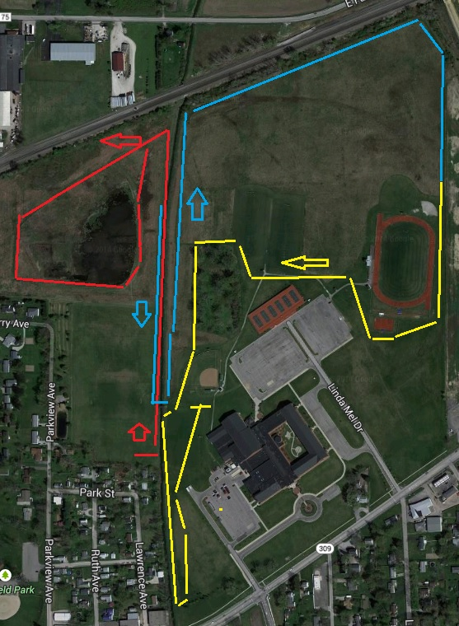
Red Line-First mile, start on west side of creek
Blue Line-2nd mile
Yellow Line-Last 1.1 miles to finish.

