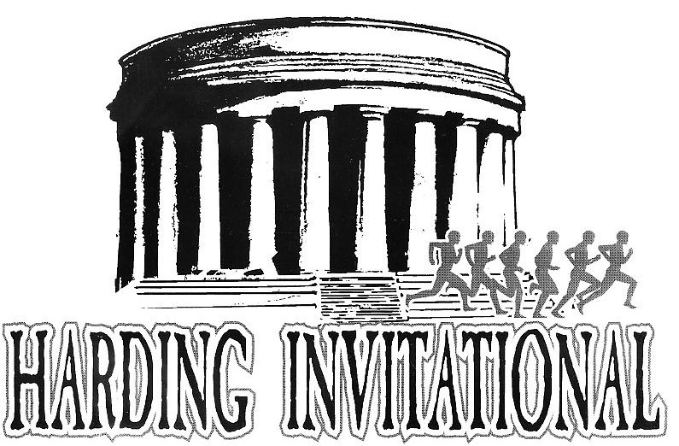
16th Annual
Saturday, October 6th, 2018
8:15 am* - 3rd grade and under, Approx.: ½ mile. Boys and girls run together, awards sorted in the chute.
8:30 am* - Grade 4-6 race, approx.¾ Mile Boys and Girls run together, awards sorted in the chute
9:15 am - Middle School Boys
9:45 am - Middle School Girls
10:15 am** - High School Boys Varsity (10 runners maximum)
10:45 am** - High School Girls Varsity (10 runners maximum)
11:15 - Boys Open
11:45 - Girls Open

Please go to www.baumspage.com log in and submit your roster for the Harding Invitational Please instruct your middle school coaches to do the same. The entry window is open now and closes October 3rd at 11:45 AM. Please do this as soon as possible. Enter everyone that may run. Please read the help page if you have not submitted an online entry before. You may e-mail me at skearns@mcspresidents.org or call 740-223-4634 with any questions.
Coaches pick up packets at the finish line/timing tent in area north of the school building near softball field.

Awards: The top three Varsity (boys/girls) and top Middle school (boy/girl) teams will receive trophies. The top 25 runners in the Varsity races will receive medals. The top 20 in the middle school races will also receive medals. You may enter any number of runners. All runners will be eligible for awards but only complete teams will be scored for the overall results.

The course will start and finish on the west side of Harding high school. It is a one-loop course on a very flat surface. The course will be held 100% on grass with one bridge crossing. Spikes of any legal length will be fine. Buses may drop off participants in east lot, and then park in east lot near soccer field. Instruct spectators to park on the east or west sides of the building (student and visitor lots).

Participating teams: Ashland, Bloom-Carroll, Buckeye Valley, Canal Winchester, Centerburg, Clear Fork, Colonel Crawford, Elgin, Findlay, Highland, Jonathan Alder, Lexington, Liberty-Benton, Mansfield Christian, Mifflin, Mount Vernon, New Albany, Newark, Northmor, Olentangy, Pleasant, Ridgedale, River Valley, Shelby, Olentangy Berkshire MS, Olentangy Shanahan MS. Fees are $75 per team, or $150 for both high school teams. (MS free w/HS)

Concessions will be available at the meet. We will also be selling t-shirts and other apparel. Please inform your athletes. There will also be a $5.00 per vehicle parking fee.

* All children’s races will cost $1 per runner, payable at the starting line. Boys and girls in each race will run together. The awards will be a medal to the first place runner (boy & girl) of each race, and ribbons to all finishers.

** Schools with fewer than five runners may compete in the varsity race, but will not be counted in the scoring.

